Урок английского языка в Музее Победы для медицинских классов
War Effort: Medicine
Рабочий лист для учителя

Introduction
Start in the Hall of Historical Verity
Ask the students to sum up the role of the Soviet Union in WWII based on what they have learnt in no more than 3 sentences, share and compare their ideas.
Hand out students’ worksheets and glossary templates (the latter is optional but could be used to ensure noting the vocabulary and/or structures that will later be used in the final production of the written work).
Task 1
Move on to the wall with the quotes by W. Churchill and F.D. Roosevelt in the Hall of Historical Verity.
Ask the students if any of their ideas are similar to the ones expressed in these quotations.
Organize work in 2 groups. Each prepares a rough translation of one of the quotes and then compares it to the original text.
Suggest students make a list of the vocabulary from the original quotes that they lacked in their translations and add the vocabulary they find most useful to the Glossary.
Group 1
Group 2
Follow-up discussion:
What are the key points that Churchill and Roosevelt make in their speeches on the role of the USSR in WWII?

Task 2
Go to the cases containing the Soviet propaganda posters in the Hall of Historical Verity. Discuss their key messages.
The students use the QR-code or the link below to see American and British propaganda posters and identify the ones addressing medical professionals. Discuss what messages they convey.
https://drive.google.com/drive/folders/1Rjv7l--qv_9P63PUrqi8pjK4LVug_609?usp=sharing
Organize work in pairs. Each student picks one of the posters to compare and contrast with the Soviet poster of their choice. The following plan is used:
• briefly describe both posters;
• say what they have in common;
• say in what way they are different;
• say which one you find more impressive and explain why.
The student’s partner comment on the talk mentioning:
- if they would add any information;
- if they agree with the conclusion; why/why not.

Task 3
Enter the Feat of the Army hall.
Read the inscription on the wall and discuss the role of medical professionals in winning the war.
The students compare their ideas with the following passage. They complete the text by inserting the appropriate words into the gaps.
In WW2, efficient medical care reduced overall losses to only 4 in each 100 wounded (WW1 8 out of 100). Better surgery, penicillin, plasma and whole blood were responsible in varying degrees, however the credit must be shared by the entire personnel of the Medical Department, whose painstaking care, surgical skill and devotion to duty under difficult and dangerous conditions saved thousands of lives! The soldier with an infection of his wounded leg, or with an open chest wound, or a mutilated face, or an injured brain, was certain to receive, after a short interval, the care of an orthopedic, plastic or neuro-surgeon – until he could reach his specialist. In general, the G.I. received the type of care which would get him to that specialist in the best possible condition. Army Nurses also gave widely varying types of skilled and sympathetic (often called Angels) service, some in field hospitals and others in general hospitals farther back. WW2 was also the first war in which Nurses automatically held officer rank!
(from https://www.med-dept.com/)
*American spelling is preserved.

The most useful vocabulary can be added to the Glossary.

Follow-up discussion:
Remember what you’ve learnt about the heroic work of medical personnel in the Feat of the People exhibition. Which activities would you call their everyday feats?

This question will also serve as a lead-in to the next stage of the lesson.

Task 4
The students read the article from the Moscow Mayor official website about the Medicine History Museum’s exhibition devoted to the Great Patriotic War. After the first quick reading, discuss what it adds to information they obtained from the Feat of the People exhibition.
Doing the tasks for detailed comprehension after each part can be organized in a variety of ways depending on the timing and the students’ level: doing all tasks or some of them, dividing the tasks for group work or assigning them individually.
The source:
https://www.mos.ru/en/news/item/20520073/

Hard work and everyday feats during the Great Patriotic War
- An exhibition on the [Medicine History] Museum’s second floor is dedicated to Soviet medicine during the Great Patriotic War of 1941–1945. Opened in 2015 in the run-up to the 70th Victory Day anniversary, the exhibition features numerous multimedia devices, including interactive panels and multifunctional monitors. Visitors select their own guided tours, with the guide creating the appropriate atmosphere by controlling sound and visual effects by a tablet computer. This concept attracts young people and makes it possible to accommodate a large amount of information in a small area.

- True, false or not stated?
- The exhibition devoted to the medical feats was prepared after the 70th Victory Day anniversary. – F
- Guided tours can be adjusted to the visitors’ tastes. – T
- Young people attend only interactive exhibitions. – NS
- But traditional stands provide the strongest impressions. A military hospital located in the central section of the Frontline Hall symbolises the effective medical assistance system streamlined by Soviet military doctors. All Soviet medical personnel had their own clear tasks. Orderlies and nurses bandaged soldiers and evacuated them from the frontline as quickly as possible. Doctors examined wounded soldiers at medical battalions and acted according to the situation. Emergency onsite surgery was performed, some soldiers were treated at medical battalions and others were sent to large hospitals behind the lines or received disability retirement. This system made it possible to return up to 70 percent of wounded service personnel to active duty.

- What were their responsibilities?
Copy the duties into the appropriate columns: bandaging, evacuation, examination, operating.

Orderlies and nurses | Doctors
bandaging | examination
evacuation | operating

- What can you see in these pictures? What do you think their connection is to the medical issues of wartime?
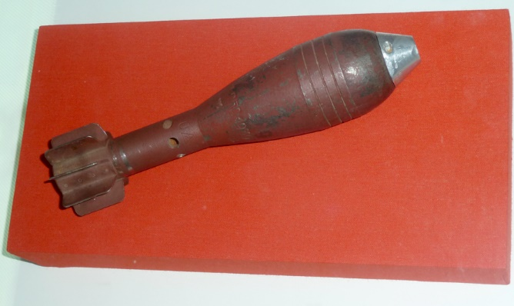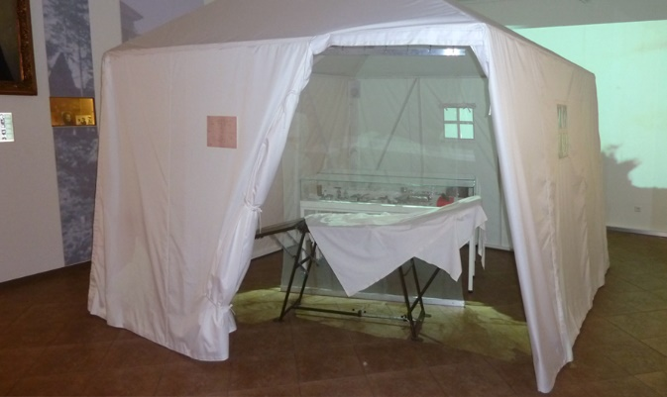

- Here you can see a 50-mm German anti-personnel mine inside a tent. In 1942, military surgeon Arkady Razdyakonov, a graduate of the First Moscow Medical Institute, removed the mine from a machine gunner’s leg. Operations like this were extremely rare during the entire war. As the mine could explode anytime, an orphan nurse volunteered to assist. The operation proved successful, combat engineers defused the mine, and it became a family relic. In 2013, Mr Razdyakonov’s son gave it to the museum.

- What’s that? Can you determine the origin of this object? What role might it have played in a medical emergency?
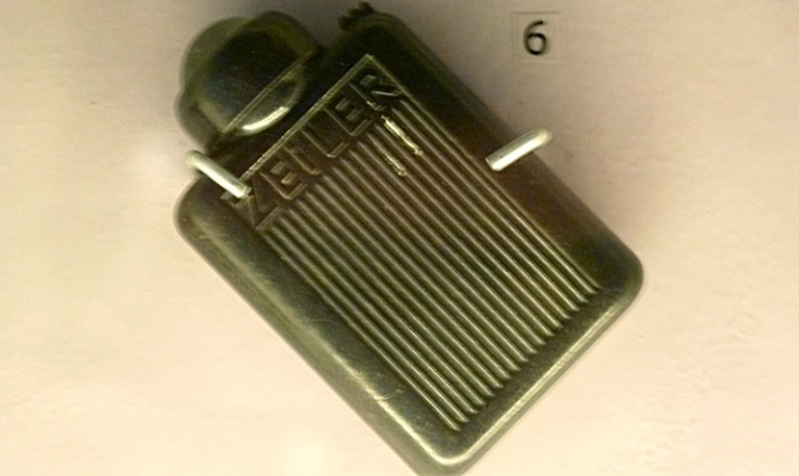
- This captured German flashlight seems out of place at a stand dedicated to female doctors at the front, but it made another medical feat possible. A Red Army soldier used the flashlight to illuminate the abdomen of his friend who was wounded in Berlin after its capture by Soviet forces, while doctor Yelena Makeyeva operated on her patient on a local street. Her hospital was about to redeploy, and the wounded soldier was fortunate because doctor Makeyeva had her medical bag on hand. The soldier recovered and wrote to his saviour many times, thanking her, and she kept the German flashlight for many years.

- Identify the objects in the picture. How may they have been used for medical purposes during the war?

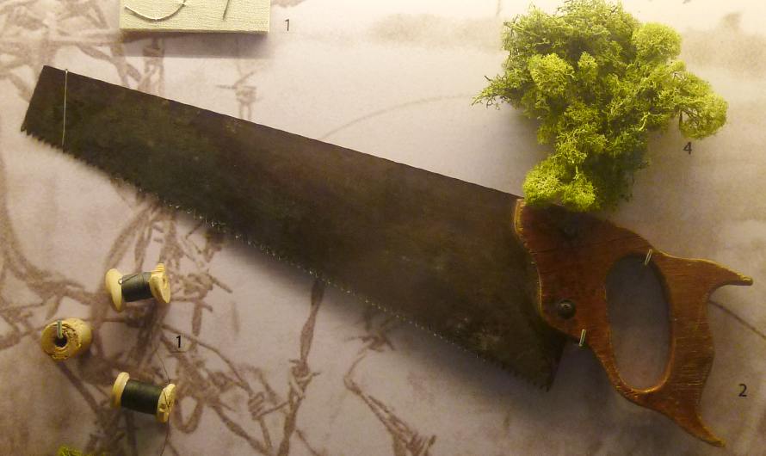
- Another stand has no authentic exhibits, but nevertheless reflects historical truth. Table knives served as scalpels, joiners’ saws were used for amputations and moss and wires helped to effectively dress wounds. All this was recreated through the recollections of Doctor Sergei Altayev, another First Moscow Medical Institute graduate who spent almost the entire war at a camp for prisoners of war and who continued to treat other inmates there.

- Identify the following in the pictures (A – D):
abdomen pain, saw, scalpel, wound dressing.

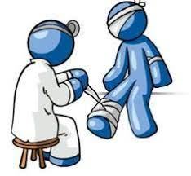  A wound dressing | 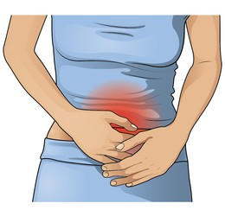  B abdomen pain
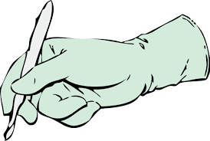  C scalpel | 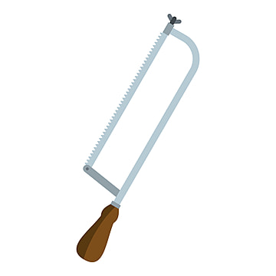  D saw

- The museum’s exhibits can tell us about many miraculous recoveries and heroic feats. But many heroes would simply shrug off these stories because, in their opinion, they were simply doing their job.

- Find the mentions of these people in the article. Who does each article of information refer to?

 | First Moscow Medical Institute graduate | Removed a dangerous object | Operated outside | Worked while imprisoned | Had help from a non-medical assistant
Arkady Razdyakonov | + | +
Yelena Makeyeva |  |  | + |  | +
Sergei Altayev | + |  |  | +

- Which idea do these people’s stories illustrate?
- First Moscow Medical Institute was the best education facility to study medicine before the war.
- The museum’s collection largely depends on contributors who participated in the war.
- Soviet doctors and other medical professionals managed to fulfil their duties even in dire circumstances.
- These doctors changed the principles of emergency treatment.
- What does the phrasal verb “shrug off” in Paragraph VII mean?
- to move one’s shoulders
- to treat something as unimportant
- to feel shy and ill at ease
- to be proud of something

The article can also be used to expand the Glossary.

Task 5
Divide the whole group into three teams to take a quick tour around the Feat of the Army hall and take notes on the following:
Team A: what kind of injuries could be caused by the weapons presented;
Team B: what kind of obstacles medical professionals had to face while doing their jobs during the war action;
Team C: what kind of medical issues and disruptions in medical care people had to face during the Siege of Leningrad.
After completing their column, the teams get back together and exchange information.
Injuries | Obstacles | Siege Medical Issues

Task 6
Having the table as scaffolding, the students regroup and discuss the following:
- sum up the major difficulties medical professionals had to overcome during the war;
- think of the key changes that have taken place in the medical sphere since the war;
- how can the issues you’ve discovered be resolved today considering scientific and technological progress?
The groups present their conclusions to other groups and compare ideas.

Task 7
Return to the Hall of Historical Verity.
Find the infographics titled Freedom for the West, Salvation for the East.
The final production task is writing a report based on the presented data with the addition of a section on the contribution of medical professionals based on what the students have learnt during the day.
The following plan is to be used:
– make an opening statement on the subject of your report;
– summarise the information by selecting and reporting the main features;
– make comparisons where relevant;
– give an overview of the medical professionals' contribution to the war effort;
– draw a conclusion.
It is recommended to assess the content (points covered, completeness), style and register (neutral or formal, appropriate linking), structure (paragraphs, logic and cohesion) and language (appropriate and correctly used vocabulary and grammar, spelling and punctuation).

Кейс 1 (базовый уровень)
The students are to write an informal letter using the information from the English version of the Museum’s website.
https://victorymuseum.ru/for-visitors/museum-for-china/en/
The task is as follows.
Use the information provided to answer the following letter you received from your English-speaking friend Debby.
…I’m really looking forward to my trip to Moscow! I’m especially interested in visiting the Victory Museum. As you may remember, I’m a fan of military history. How can I learn about the battles of the Great Patriotic War in the museum? Is there any information on the weaponry used during WWII? I’m going to travel with my parents and my 7-year-old brother. Will we be able to go on a guided tour?
By the way, I’ve decided to become an army engineer…
Write a letter to Debby. Use the information leaflet below to answer her questions. Ask three questions about her future profession.
Write 100 – 140 words. Remember the rules of letter writing.
The assessment is based on the National State Examination criteria.
Объём высказывания соответствует поставленной задаче: 90–154 слова
1. Решение коммуникативной задачи (Содержание) | Аспект 1. Ответ на вопрос 1 (упомянуты диорамы и панорамы музея)
 | Аспект 2. Ответ на вопрос 2 (упомянуты экспозиции на открытом воздухе)
 | Аспект 3. Ответ на вопрос 3 (упомянута экскурсия «Weapon of Victory»)
 | Аспект 4. Три вопроса о будущей профессии заданы
 | Аспект 5. Нормы вежливости соблюдены: ссылка на предыдущие контакты; благодарность за полученное письмо; надежда на последующие контакты
 | Аспект 6. Стилевое оформление выбрано правильно: обращение, завершающая фраза, подпись автора в соответствии с неофициальным стилем
 | ИТОГОВЫЙ БАЛЛ (максимальный балл – 2)
2. Организация | Логичность
 | Деление на абзацы
 | Средства логической связи
 | Обращение на отдельной строке
 | Завершающая фраза на отдельной строке
 | Подпись на отдельной строке
 | Адрес автора в правом верхнем углу (можно краткий)
 | Дата под адресом
 | ИТОГОВЫЙ БАЛЛ (максимальный балл – 2)
3. Языковое оформление текста. ИТОГОВЫЙ БАЛЛ (максимальный балл – 2) *
* 2 балла: орфографические и пунктуационные ошибки практически отсутствуют (допускается 1–2 лексико-грамматические ошибки И/ИЛИ 1–2 орфографические и пунктуационные ошибки)
1 балл: 3–4 лексико-грамматические ошибки И/ИЛИ имеется 3–4 орфографические и пунктуационные ошибки
0 баллов: 5 и более лексико-грамматических ошибок И/ИЛИ орфографических и пунктуационных ошибок

Кейс 2 (углубленный уровень)
This task is suitable for those aspiring to deal with academic, engineering or science-related translation.
The students need to read an article on the Soviet engineers’ contribution to winning the war and choose a passage for translation into English. Their work on the translation can be based on the following plan.
- Analyze the text:
- which grammar structures will you need to use?
- Which words and phrases do you need to look up?
- Are there any style and register peculiarities?
- Make a glossary of necessary vocabulary.
- Write a draft of the translation.
- Do error correction.
- Exchange translations with your peers, assess each other’s works and provide feedback. Consult with your English teacher. Edit the translation based on your peers’ and teacher’s recommendations.
Possible ways of organizing work and presenting results:
- All students translate the same passage. A contest for the best translation is organized.
- The whole article is divided equally among the students. The ultimate goal is to get a consistent translation of the article.

